Let’s Talk About Anxiety
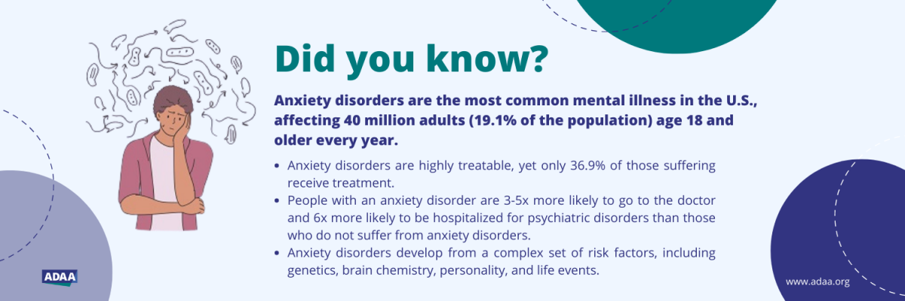
Anxiety is an emotion characterized by feelings of tension, worried thoughts, and physical changes like increased blood pressure. Anxiety is not the same as fear, but they are often used interchangeably.
Common symptoms include but are not limited to:
- Constant worry
- Feeling restless or always “on edge.”
- Fatigue
- Struggling to focus
- Feeling snappy or irritable
- Tense muscles
- Difficulty falling or staying asleep
The most common anxiety disorders include:
- Specific phobias
Phobias could be related to animals (like spiders, cats or dogs), the natural environment (like heights, storms or being in water), locations (like airplanes, elevators, bridges or enclosed places). The anxiety peaks when you encounter specific things – that is, it is experienced when you are faced with a dog or a bridge or maybe you avoid things to avoid the trigger (you drive the long way to avoid the bridge).
- Social anxiety disorder
This is a fear of being around other people or in social situations. Social anxiety involves fear of being watched by or judged negatively by others.
- Generalized anxiety disorder (GAD)
This is overall worry about many different things. GAD causes fear, a constant feeling of being overwhelmed and excessive worry about everyday things. It’s feeling exhausted all the time because your brain is in overdrive. It’s headaches, aching muscles, and nights spent tossing and turning.
- Separation anxiety
This is an excessive anxiety concerning separation from attachment figures or items.
- Panic disorder
This is an abrupt surge of intense fear or discomfort. Panic attacks may feel like heart palpitations or pounding, shortness of breath, or feel like you are going crazy.
Avoidance may seem like a good idea, but is it really? People often respond to something that makes them anxious with avoidance. If you’re nervous about the party, it seems easier to just not go to the party. If you are afraid to order in a restaurant, then maybe you convince yourself that you would prefer to eat at home. If you are afraid of elevators, then you always take the stairs.
Avoidance always leads to more anxiety. The more you avoid something that makes you anxious, the harder it will be to do that thing in the future.
Tips and things to try:
Try diaphragmatic and square breathing techniques.
Diaphragmatic breathing involves taking a deep breath from your diaphragm. Your stomach should expand as you breathe in. Square breathing techniques involve taking a deep breath in for five counts, holding this deep breath for five counts, exhaling for five counts and finally holding for five counts before repeating. Focus and refocus on your breath rather than the stressful event.
Challenge your thoughts.
This involves not judging situations, focusing on what you're feeling, and identifying what's in your control. It can also be important to focus on the facts of the situation. Sometimes your anxious and depressive thoughts are not always based in facts, but rather about assumptions or driven by emotions.
Ask yourself:
- What am I feeling?
- What are these emotions?
- How would I like the situation to turn out?
- What are the facts?
Then identify small, specific goals to get to your desired outcome. If you immediately attach a negative thought to a situation, the result is likely to be avoidance and increased anxiety.

When you’re anxious or worried, your thoughts may become distorted. Common negative patterns of thinking include:
- overgeneralizing
- all-or-nothing thinking
- jumping to conclusions
- thinking in “shoulds”
- catastrophizing
Focus on your senses
One of the best ways to get out of your head is to bring yourself back to the present. Let your senses can help guide you out of spiraling, anxious thoughts.
A good technique is the 5-4-3-2-1 exercise to tune into your surroundings:
5: Identify five things you can see around you — anything from a pen on the table, clock on the wall, to a stray cat hair on your pants.
4: Find four things you can touch. Notice the soft texture of your pillow or the smooth coolness of your water glass.
3: Listen for three things around you. It might be birds chirping, coworkers outside your room, or a clock ticking
2: Name two things you can smell. Maybe it’s your perfume, coffee nearby, or lunch.
1: Find one thing you can taste. Maybe a piece of gum or chocolate.
It can be a good idea to keep a few items nearby for times when you might be anxious. Keep a toy/pillow/keychain with a nice texture, an aromatherapy item, and some mints.
Have a mantra
When you’re in a state of anxiety, your brain is trying to convince you that you that there is danger or something bad is going to happen. So, it can be helpful to say things out loud (or in your head) to contradict those messages your brain is sending you.
When your anxiety goes up, repeat these words to yourself:
- In this moment, I am OK.
- This moment will pass
- Let go of what I cannot change
- One step at a time

If you need help with this, talk to a trusted friend, family member or talk to a professional.

